Hands-on Exercise No. 1 — Solution
DigiSkills 3.0 Batch-04 | Cloud Computing | AWS Free Tier Account & Root MFA
IMPORTANT: Insert your own AWS screenshots at the marked locations. Never include passwords, payment-card details, MFA secret keys, recovery codes, or one-time verification codes.

Task 1 — Create an AWS Free Tier Account (8 Marks)

Step 1 — Open AWS Account Registration
Open the official AWS website and select “Create an AWS Account.” Begin the account registration process.
Screenshot 1: AWS registration page showing the “Create an AWS Account” option.

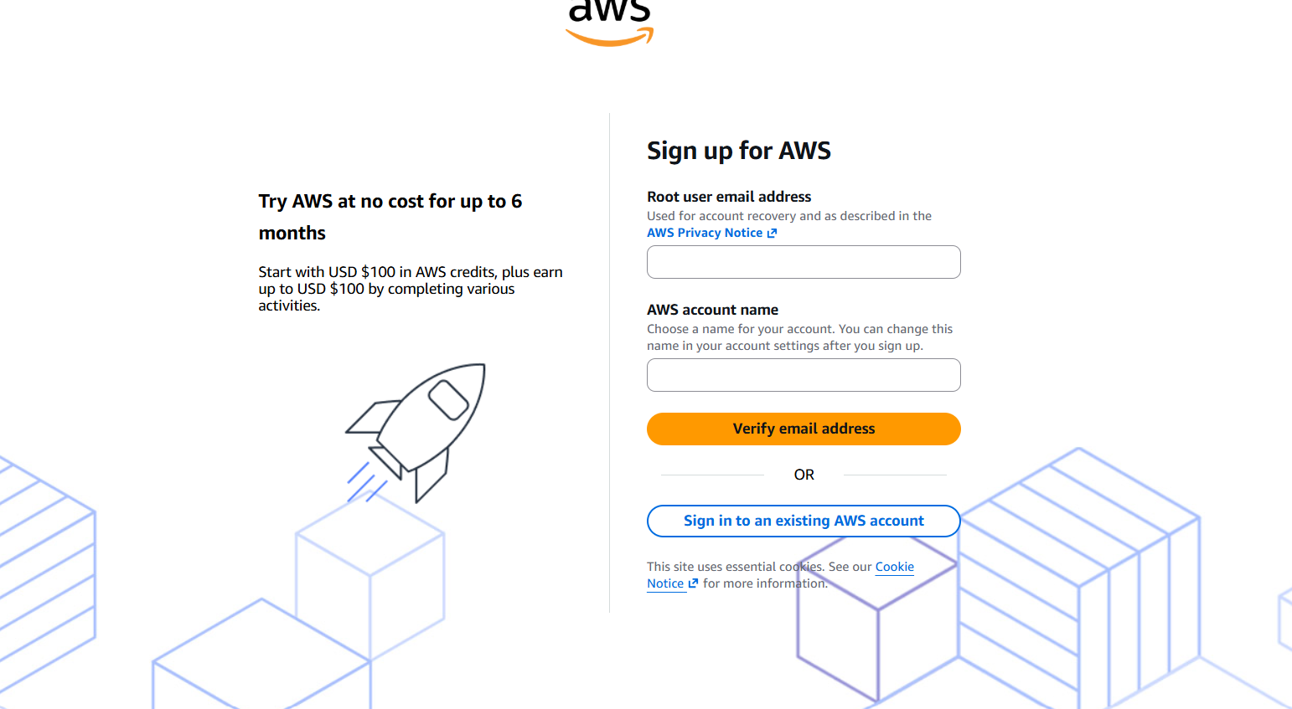
Step 2 — Enter Email, Account Name and Password
Enter a valid email address, choose an AWS account name, and create a strong password. Use a unique password.
Screenshot 2: Registration form with personal credentials hidden or cropped.

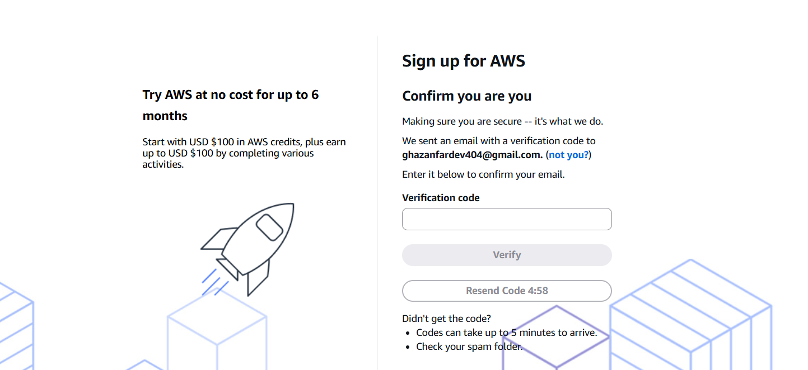 Step 3 — Verify Email Address
Complete the email verification process by entering the verification code sent to the registered email address.
Screenshot 3: Email verification screen. Hide private information.



Step 4 — Enter Contact Information
Provide the required contact information, including full name, phone number and address.
Screenshot 4: Contact-information page with private details masked.

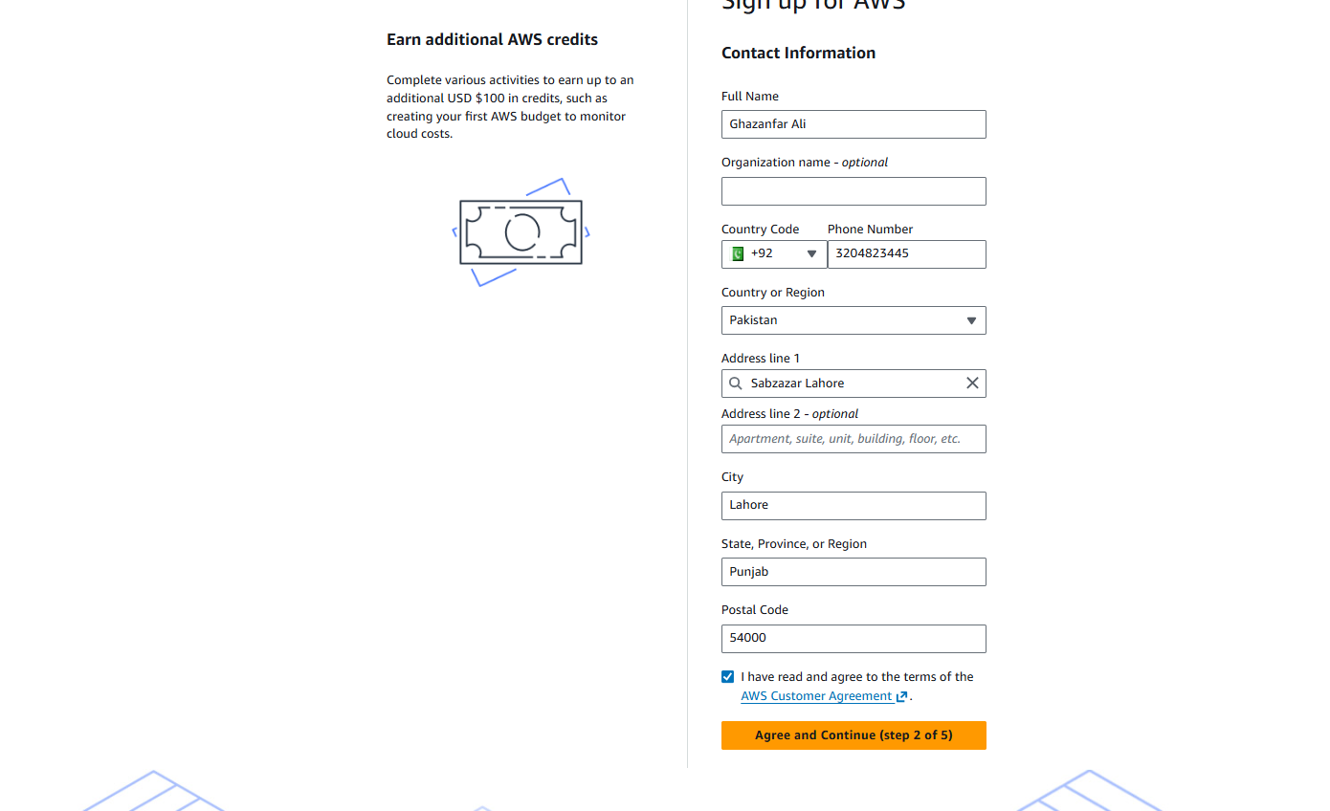 Step 5 — Add a Valid Payment Method
Add a valid credit or debit card as requested during registration. Do not expose card details.
Screenshot 5: Payment-method page with card number, CVV and expiry completely hidden.

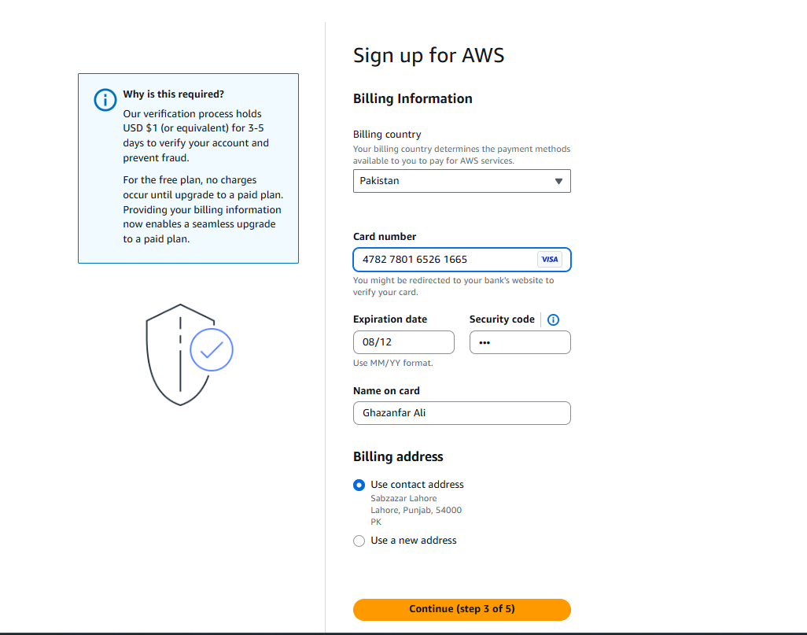

Step 6 — Complete Identity Verification
Complete identity verification using the available SMS or voice-call method.
Screenshot 6: Identity-verification step completed, with private information hidden.

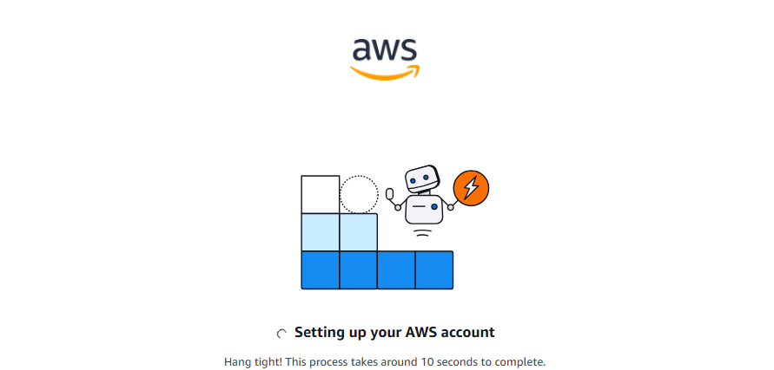Step 7 — Select Basic Support — Free
Select Basic Support — Free and complete the account creation process.
Screenshot 7: Support-plan selection showing Basic Support — Free.

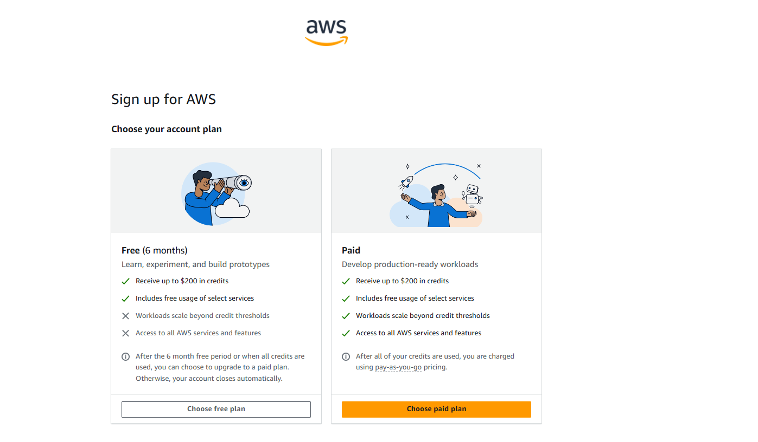 Task 2 — Enable and Verify Root User MFA (2 Marks)

Step 8 — Sign in as Root User
Sign in to the AWS Management Console using the Root user option.
Screenshot 8: AWS sign-in page with Root user selected. Hide the email address if necessary.
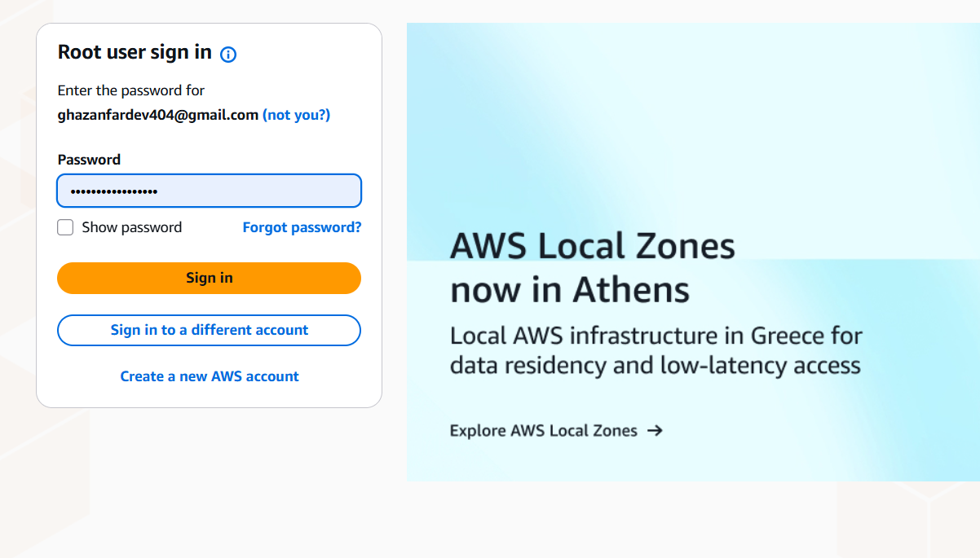

Step 9 — Enable MFA for Root User
Open the root-user security settings and enable Multi-Factor Authentication (MFA). Use Google Authenticator, Microsoft Authenticator or Authy. Complete setup by entering the generated MFA code.
Screenshot 9: Root-user MFA setup screen. Do not expose the secret setup key or recovery information.

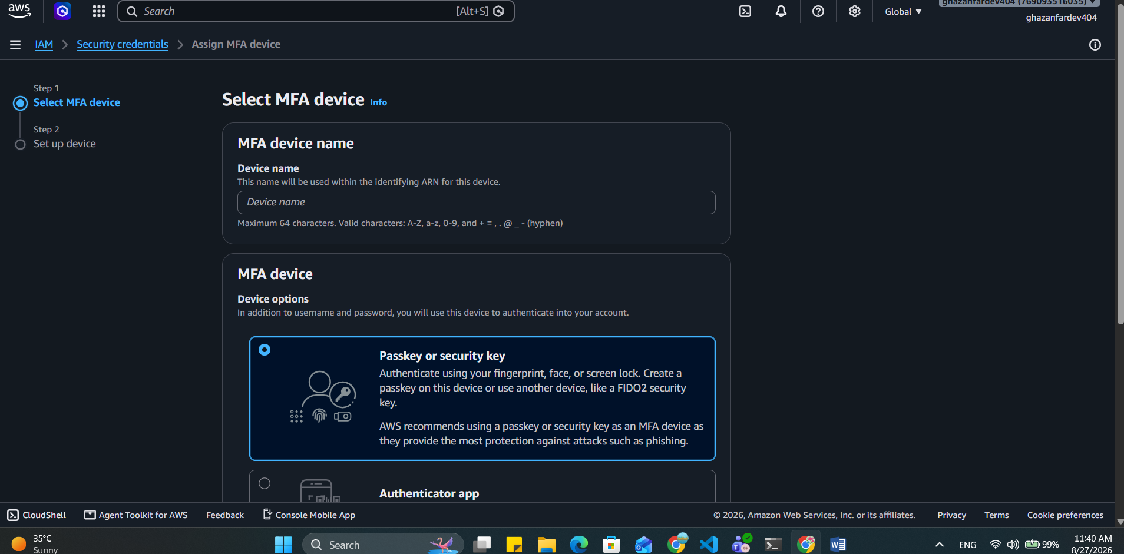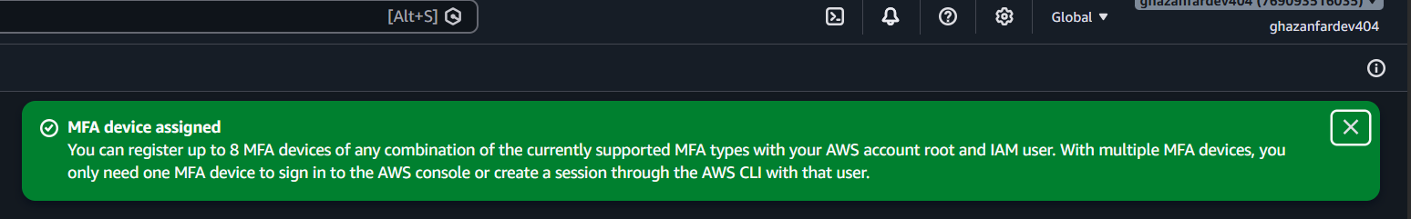

Step 10 — Sign Out and Verify MFA
Sign out and sign in again as Root user. Enter the password and then the current MFA code. Successful sign-in confirms MFA is working.
Screenshot 10: MFA challenge/sign-in verification screen. Do not show the actual MFA code.

